LANDS’ END– DIGITAL ASSET SPECIFICATIONS Rev. 2/1/21
MINIMUM REQUIREMENTS [Images & Videos]
Images must be professionally styled, lit, captured, and retouched

Image File Specifications:
Pixel Depth = 2000 x 3000 pixels min (larger is fine)
ColorSpace = SRGB or Adobe RGB
Aspect Ratio = 2x3
File Background = White (255) no shadows
File Format = .tif or uncompressed JPG
No Layers = Flatten to background

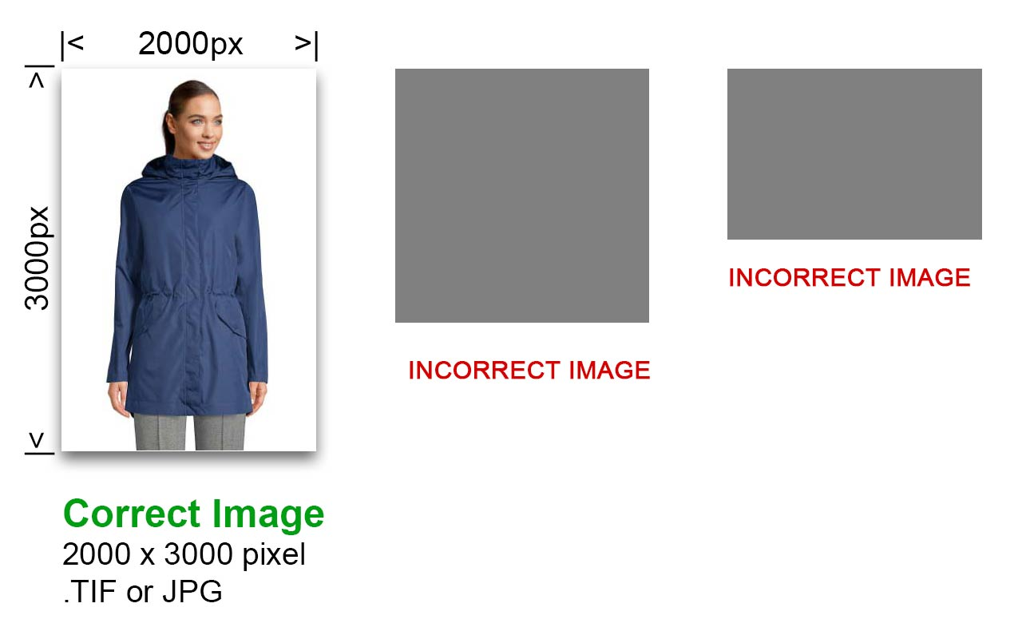
Metadata in file IPTC Description Field
(LE Style Number) - (Product Name)
(Product Color) - (Color Code)
(LE Product Category)
(Season)
Vendor supplied image / (vendor name)

Example text:
518013 - Gabor Muir Sandal
Red Kombi Suede - YXO
CAT 56
SS20
Vendor supplied image / GABOR
Accuracy: Image must accurately represent the product
Quality: Product must be clear and in focus at 100% magnification
Styling: All product imagery is to be captured according to the Lands’ End-approved lighting, set and styling guides, and must include appropriate additional views (ALTs)
Refer to Lands’ End Style Guide provided
Usage Rights: Document Who (model) | When (length of time) | Where (channel specific rights)

General Image Content Rules:
Image Review: Incoming imagery to be reviewed by the Lands’ End Product Page Production & Digital Merchandising teams
Identical Items with Multiples Sizes: Require only one image (i.e. shirt that is offered in sizes XS-XL only needs one image submitted)
No Added Graphics: Including emblems, awards, badges, overlays, logos, watermarks, etc.
Minimums: Require ONE image for each color
Additional lifestyle, alternate images, details, features, etc. are acceptable
Maximums: No more than 8 images for each color

Uploading Assets:
Upload to Portal: Vendor is responsible for uploading assets into a vendor-specific portal in the Lands’ End Censhare DAM
A specific Vendor Login has been provided with the Digital Asset Delivery email

Image Naming Requirements:
File Naming: Should be divided into parts by underscores where applicable (see below chart)
Lands’ End style number
Season
Position of Image Identifier
Color Code

*Please use all uppercase letters and no spaces in the name

Style #: Number must match exactly as displayed in the Lands’ End Merchandising System. Lands’ End to provide those numbers to Vendor.
Season: Lands’ End to provide a guide to this with the Conversion Chart (sent once LE processes data)
Position of Image identifier: Maximum images = 8
- FF: Front view of image
- FB: Back view of image
- FS: Side view of image
- F1: Alternative view/lifestyle image
Color Naming: Each image must contain a 3-letter color code representing the Lands’ End color name

If vendor can’t provide the LE provided data (Style #, color code), then we’ll need the following from the vendor in the name:
  - Vendor number
  - Vendor description
  - Vendor color name

Example File Name: LEStyle#_Season_Pos#_ColorCode.tif
The following examples are the minimum requirements when assigning names to assets.

Lands End Style # | Season | Pos # | Color Code | File Name (Pre-Assigned by Vendor)
123456 | Spring Summer 2020 – SS20 | FF Front (Spot 1) | FLO | 123456_SS20_FF_FLO.tif
123456 | Fall Holiday 2020 – FH20 | FB Back (Spot 2) | FLO | 123456_FH20_FB_FLO.tif
123456 | Spring Summer 2020 – SS20 | FS Side | BLU | 123456_SS20_FS_BLU.tif
123456 | Spring Summer 2020 – SS20 | F1 Alternative image | GRN | 123456_SS20_F1_GRN.tif

Swatch Requirements:
- Lands’ End website system requirement needs both a large swatch and small swatch for each style/color
- Small Swatch:
  - Specs: 70px x 20px
  - Naming convention: Style #_ColorCode_SS
- Large Swatch:
  - Specs: 500px X 750 px
  - Naming convention: Style #_ColorCode_BS

Lands End Style # | Color Code | Swatch Type | File Name (Pre-Assigned by Vendor)
123456 | FLO | Big Swatch | 123456_FLO_BS.tif
123456 | FLO | Small Swatch | 123456_FLO_SS.tif
123456 | BLU | Big Swatch | 123456_BLU_BS.tif
123456 | BLU | Small Swatch | 123456_BLU_SS.tif

- Recommendations when creating swatches
  - Zoom in on product to represent the color
  - Create Large swatch first – then scale down to create the Small swatch

